Our Leadership:

Senior Pastor, Steven Hansen steven@redeemersylva.org
Elders:
Lee Nickles, Ruling Elder lee.nickles@gmail.com
Jack Stern, Ruling Elder stern.artist@gmail.com
Bobby Wilson, Ruling Elder wilsonrobert1056@gmail.com

Deacons:
Griffin Johnson griffinphillipjohnson@gmail.com
Nathan Shepherd nkshepherd1872@gmail.com

Our Missionaries:

Ashley Belknap MNA Special Needs
Patrick and Regina Lennox MTW First Nations
Kate Anderson RUF Intern
Andrew and Trish Shank RUF @ WCU
Etta Farlow (Belmont University) RUF Intern
Will and Grace Stern MNA Church Planting

PCA Administrative Committee Atlanta, GA
PCA Committee on Discipleship Ministries Atlanta, GA
Smoky Mountain Pregnancy Care Center Cullowhee, NC
Highlands Presbytery Our Presbytery
Ridge Haven Conference Center Brevard, NC

Redeemer Church, PCA
86 Story Book Lane
P.O. Box 2014
Sylva, North Carolina 28779
828-586-5811
redeemersylva.org

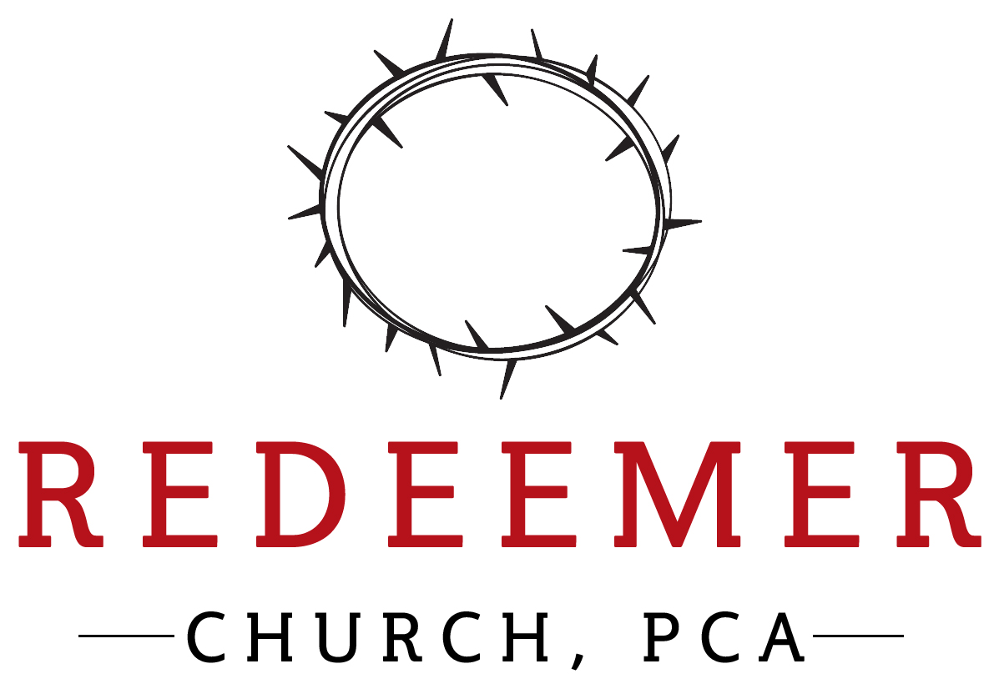

Welcome to Redeemer Church , PCA

We are thankful that you have joined us for worship today at Redeemer. Our goal every time we gather together is to have a simple worship service in which God is exalted and we are encouraged. As a church, our desire is to embrace the God of grace, build a community of grace, and proclaim the gospel of grace. If you are new to Redeemer, here is some information that you may find helpful for your visit:

Restrooms – Are located inside; please use the double glass doors. The men’s room is located immediately to your right, the women’s room is your second left, and then on your left.

Nursery – Currently, we do not offer a nursery due to COVID-19. Infants and children of all ages are welcome in corporate worship.

Bibles – If you need a Bible, please let someone know and we will get one for you.

Retiring Offering – We do not take up an offering during worship. There is an offering box in the foyer. (Just look for the double glass doors.)

Fellowship Time – Please join us after worship for good conversation and fellowship. We would love the opportunity to meet you and get to know you. Please be kind and remember to keep a safe distance from others.

Visitor Information Card – Please visit redeemersylva.org/connect to get connected with Redeemer Church and be put on our email list to stay informed.

Thank you again for joining us in worship. We look forward to meeting you and getting to know you. Please let us know if you have any questions and if we can serve you in any way.

When darkness veils his lovely face
I rest on His unchanging grace
In every high and stormy gale
My anchor holds within the veil

Chorus

His oath, His covenant, His blood
Supports me in the ‘whelming flood
When all around my soul gives way
He then is all my hope and stay

Chorus

Corporate Confession of Sin Proverbs 28:13 & Psalm 38:18
He who conceals his transgressions will not prosper, but he who confesses and forsakes them will find compassion.
For I confess my iniquity; I am full of anxiety because of my sin.

Silent Confession of Sin

Assurance of Pardon Romans 5:1
Therefore having been justified by faith, we have peace with God through our Lord Jesus Christ.

Prayer for Our Needs

Scripture Reading Romans 15:13
May the God of hope fill you with all joy and peace in believing, so that by the power of the Holy Spirit you may abound in hope.

Prayer for Understanding

Sermon Pastor Steven Hansen
“Scandalous Grace Part 1: Judah, Tamar and Jesus”

Prayer of Thanksgiving

Hymn of Thanksgiving “O Come, O Come, Emmanuel”
O come, o come Emmanuel
And ramson captive Israel
That mourns in lonely exile here
Until the Son of God appear

Chorus

Rejoice! Rejoice! Emmanuel
Shall come to thee, O Israel

Benediction Romans 15:13
May the God of hope fill you with all joy and peace in believing, so that by the power of the Holy Spirit you may abound in hope.

Sermon Notes

Lord’s Day Worship
November 29, 2020
First Week of Advent
Theme: Hope

Welcome and Announcements Call to Worship Psalm 33:16-17 & 20-22

The king is not saved by his great army; a warrior is not delivered by his great strength. The war horse is a false hope for salvation, and by its great might it cannot rescue. Our soul waits for the Lord; he is our help and our shield. For our heart is glad in him, because we trust in his holy name. Let your steadfast love, O Lord, be upon us, even as we hope in you.

Prayer of Adoration

Hymn of Adoration “My Hope Is Built On Nothing Less”

My hope is built on nothing less
Than Jesus’ blood and righteousness
I dare not trust the sweetest frame
But wholly lean on Jesus’ name

Chorus:
On Christ the solid rock I stand
All other ground is sinking sand
All other ground is sinking sand

